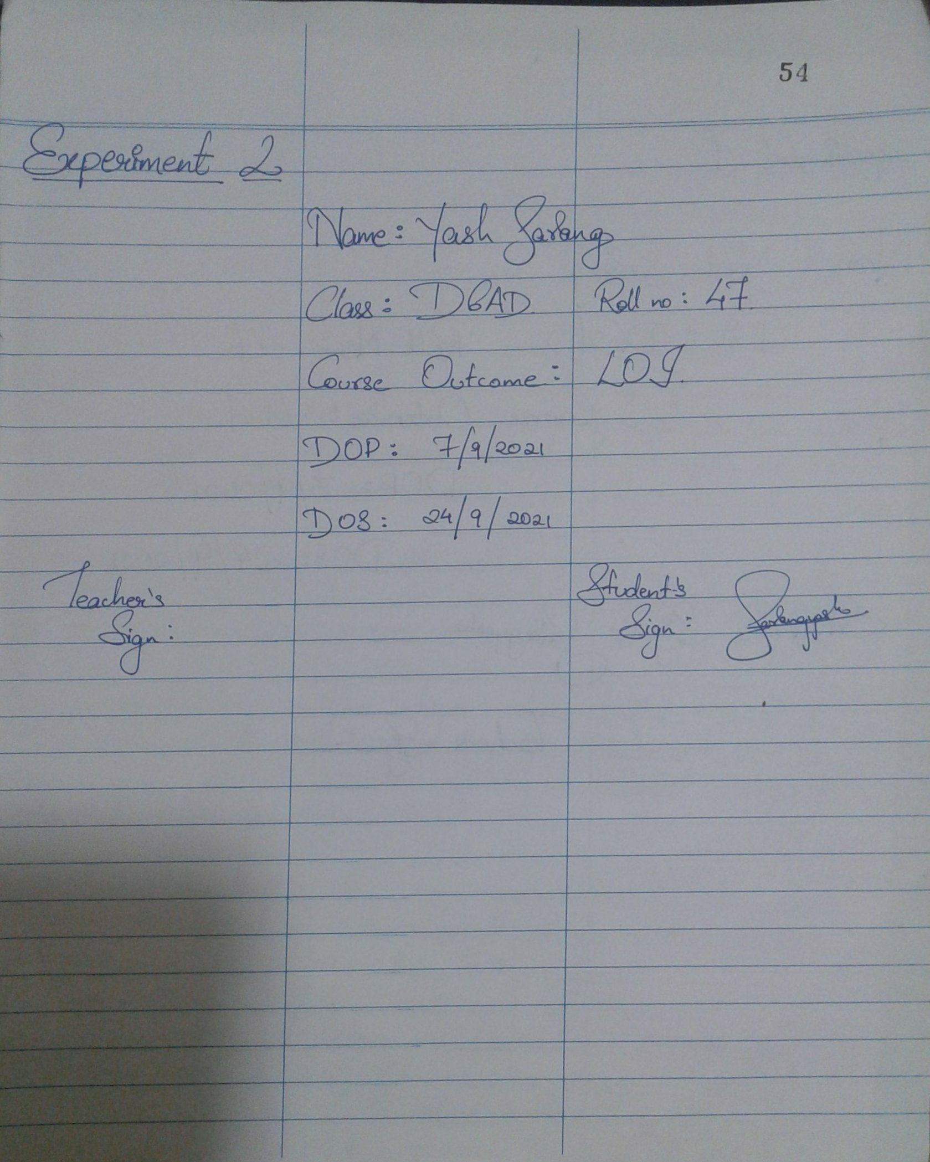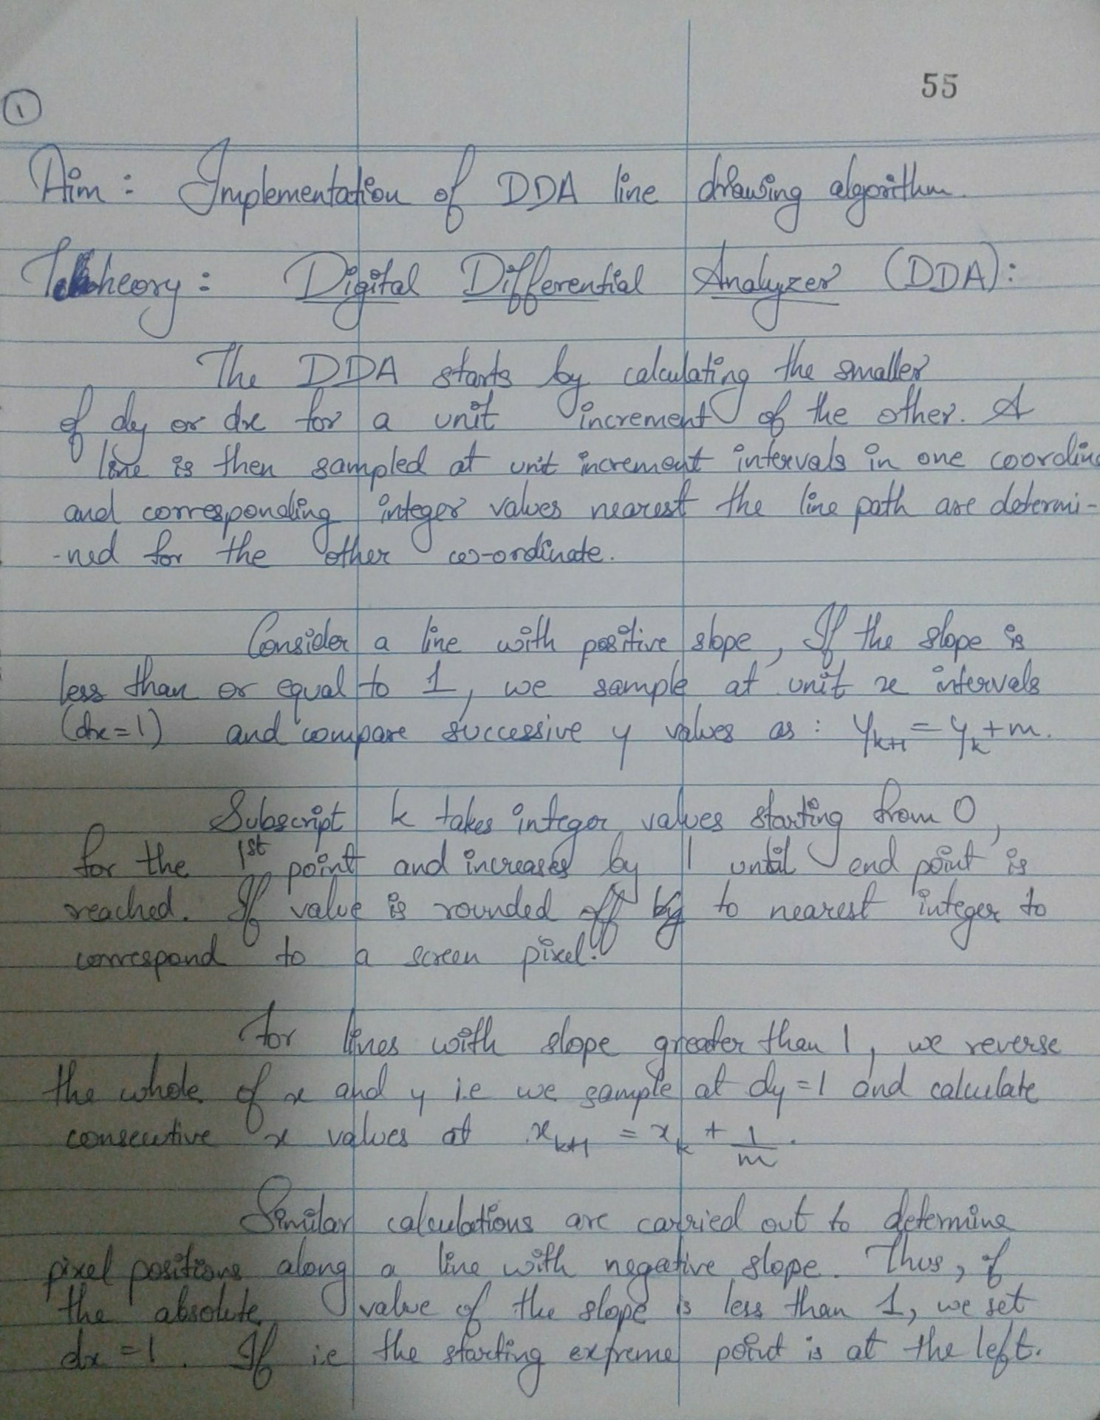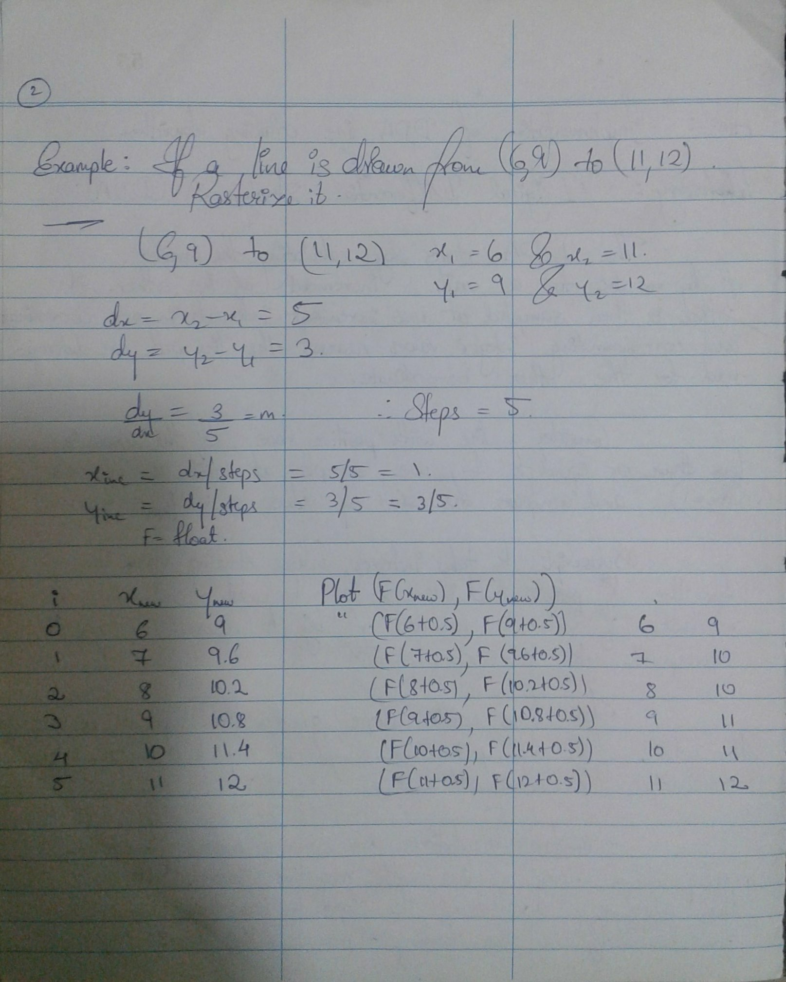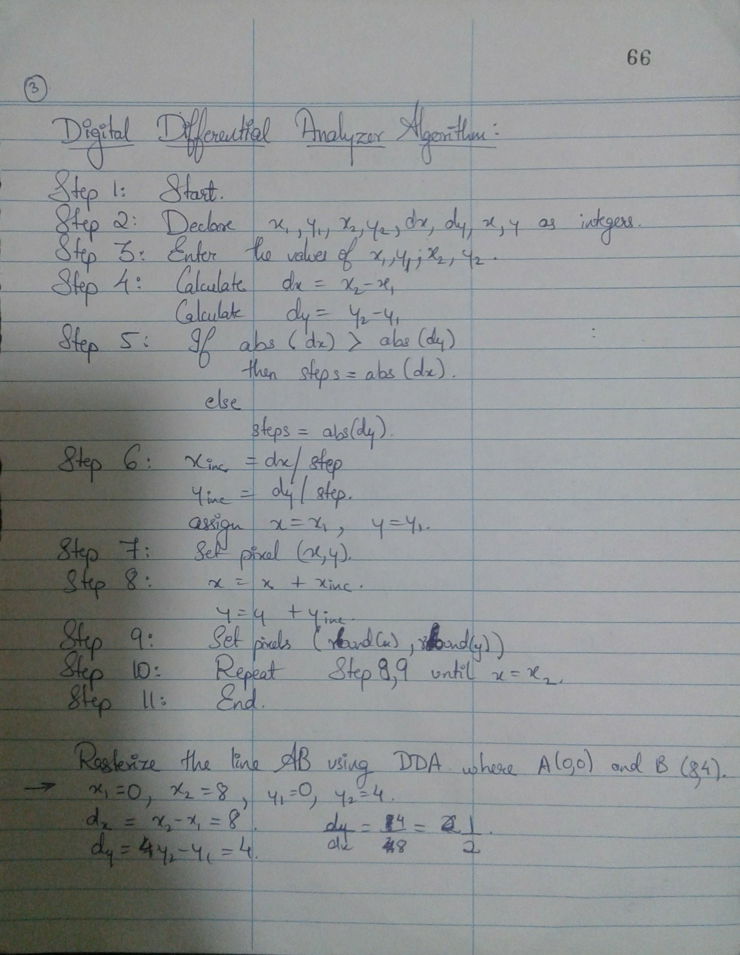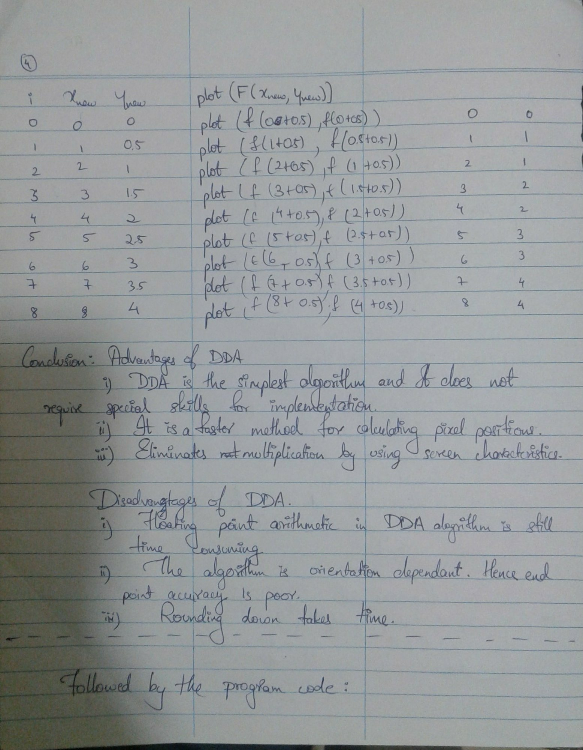

__________________________________________________________________________________________________

**CODE:**

#include <graphics.h>

#include <conio.h>

#include <stdio.h>

#include <stdlib.h>

#include <math.h>

void main()

{

int gd=DETECT,gm,i,errorcode;

float x,y,dx,dy;

int steps,r;

int x0,x1,y0,y1;

int color_val;

initgraph(&gd,&gm,"C:\\TURBOC3\\BGI");

errorcode=graphresult();

if(errorcode!=0)

{

printf("Graphics error:%s\n",grapherrormsg(errorcode));

printf("press any key to halt:");

getch();

exit(1);

}

setbkcolor(BLACK);

x0=0,y0=0,x1=8,y1=4;

dx=(float)(x1-x0);

dy=(float)(y1-y0);

steps=0;

if(dx>=dy)

{

steps=dx;

}

else

{

steps=dy;

}

dx=dx/steps;

dy=dy/steps;

x=x0;

y=y0;

i=1;

while(i<=steps)

{

putpixel(x,y,RED);

x+=dx;

y+=dy;

i+=1;

}

//displaying thick lines

x=x0;

y=y0;

getch();

cleardevice();

outtextxy(150,50,"THICK LINE");

for(steps;steps>0;steps--)

{

x=x+dx;

y=y+dy;

delay(20);

putpixel(floor(x+0.5),floor(y+0.5),WHITE);

putpixel(floor(x+1.5),floor(y+1.5),WHITE);

putpixel(floor(x-1.5),floor(y-1.5),WHITE);

}

//displaying dashed lines

x=x0;

y=y0;

getch();

cleardevice();

outtextxy(150,50,"DASHED LINE");

for(steps;steps>0;steps--)

{

x=x+dx;

y=y+dy;

delay(20);

if(steps%2==0)

{

putpixel(floor(x+0.5),floor(y+0.5),WHITE);

}

}

//displaying colored lines

x=x0;

y=y0;

color_val=0;

getch();

cleardevice();

outtextxy(150,50,"COLOR LINE");

for(steps;steps>0;steps--)

{

x=x+dx;

y=y+dy;

delay(20);

putpixel(floor(x+0.5),floor(y+0.5),color_val);

color_val++;

if(color_val==15)

color_val=0;

}

getch();

closegraph();

} __________________________________________________________________________________________________

**OUTPUT:**





